**CrossConnect Integration**

|  |  |  |  |
| --- | --- | --- | --- |
| **Type** | **Name** | **ID** | **Deployed On** |
| Restlet | CROSSCONNECT GET PO RECORDS | customscript_crossconnect_get_po_records |  |
| Restlet | CROSSCONNECT GET IR RECORDS | customscript_crossconnect_get_ir_records |  |
| Suitelet | CROSSCONNECT SET TO EXPORTED | customscript_crossconnect_set_to_exported |  |
| User Event | CROSSCONNECT SET LINE NUMBER | customscript_crossconnect_set_line_number | Purchase Order |
| Suitelet | CROSSCONNECT CREATE INVOICE | customscript_crossconnect_create_invoice |  |
| Saved Search | Billing Transaction Search **SCRIPT** | customsearch_billing_transaction | Transaction |
| Saved Search | Item Check **Script** | customsearch_item_check | Transaction |
| Saved Search | Retrieve Item Receipts **SCRIPT** | customsearch_retrieve_item_receipts | Transaction |
| Saved Search | Retrieve Purchase Orders **SCRIPT** | customsearch_retrieve_purchase_orders | Transaction |
| Saved Search | Search for Item Name **Script** | customsearch_search_for_item_name | Transaction |
| Transaction Body Field | Record Action | custbody_record_action | Purchase Order, Item Receipt |
| Transaction Body Field | Exported | custbody_exported | Purchase Order, Item Receipt |
| Transaction Line Field | Line Number | custcol_line_no | Purchase Order, Item Receipt, Vendor Bill |
| Transaction Line Field | Split Bill | custcol_split_bill | Vendor Bill |

NetSuite Components:

**Workflows**

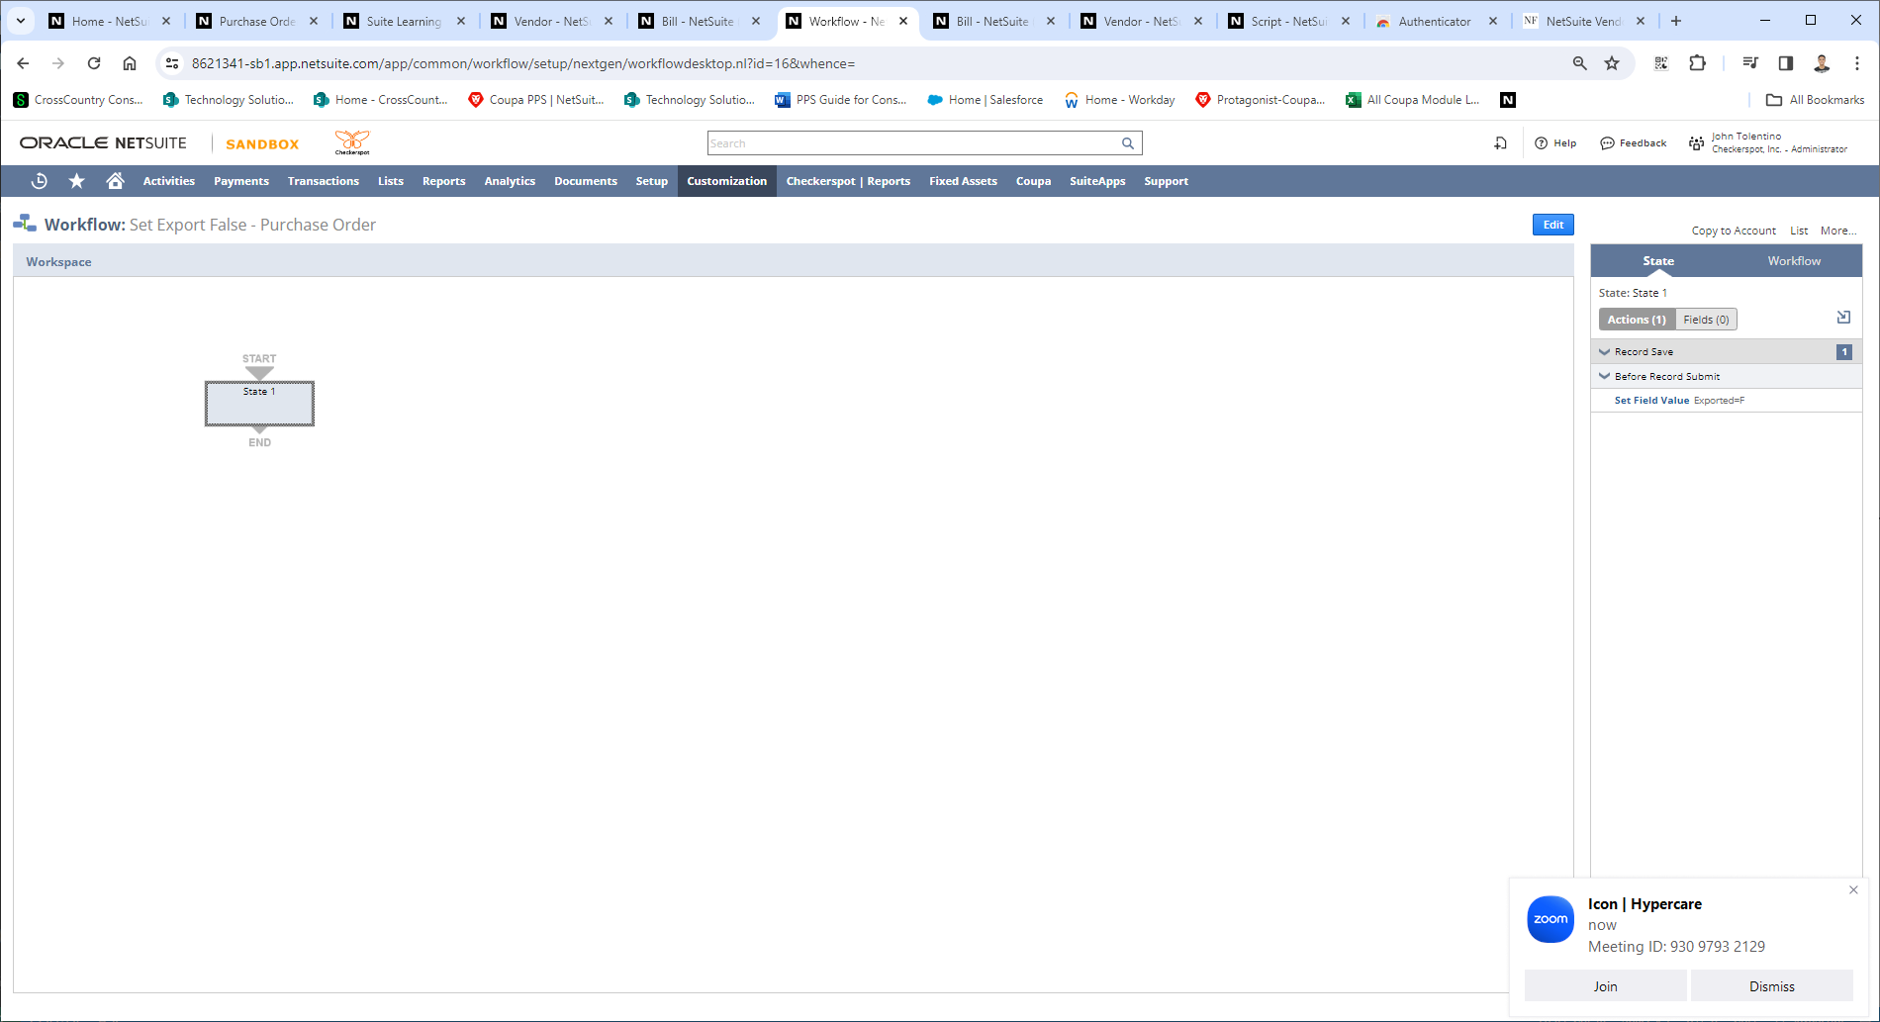

**Saved Searches**

Retrieve Purchase Orders **SCRIPT**

|  |
| --- |
| customsearch_retrieve_purchase_orders |
|  |

Retrieve Item Receipts **SCRIPT**

customsearch_retrieve_item_receipts

Billing Transaction Search **SCRIPT**

customsearch_billing_transaction

Item Check **Script**

customsearch_item_check

Search for Item Name **Script**

customsearch_search_for_item_name

